Module 9.2- Applied Prototyping Using a Group Exercise
CSD200
February 28, 2026

Pets-R-Us Website Expansion Project
Group Assignment Submission
Team Alpha Members
- Sheridan Dela Cruz
- Marco Rodriguez
- Megan Mossier
- Garvin Stewart

Activity 1- User Story Elicitation
The four team members completed elicitation interviews in the Product Owner, Co-Product Owner, and Developer roles. Each member generated user stories based on their interviews. The following list is a consolidated, de-duplicated, and prioritized set of user stories representing all team input.
Final Prioritized User Stories
1. Online Appointment Scheduling
As a customer, I need to schedule grooming, training, or boarding appointments online so that I can book services at any time without calling the store.
2. Accurate Real-Time Availability
As a staff member, I need the system to show accurate, real-time availability so that I can avoid double booking and manage daily capacity confidently.
3. Automated Scheduling Rules
As a product owner, I need the booking system to enforce correct durations, capacity limits, and time blocks for each service so that appointments follow operational guidelines without manual oversight.
4. Appointment Confirmation & Reminders
As a customer, I need clear confirmation and reminders for my appointments so that I can trust my booking went through and plan my visit confidently.
5. Appointment Modification (Cancel/Reschedule)
As a customer, I need to easily modify or cancel my appointment online so that I can manage my plans without calling the store and the system can apply any cancellation policies automatically.
6. Pet Profile Management
As a customer, I need to register and update my pet’s details so that staff are prepared for the specific size, needs, and behavior of my dog before the appointment.
7. Groomer Daily Schedule View
As a groomer, I need to see my scheduled appointments for the day so that I can prepare for each pet and manage my workload.
8. Customer Account History & Quick Rebooking
As a returning customer, I need to view my past appointments and saved pet profiles so that I can quickly rebook my preferred services and receive personalized recommendations.
9. Secure Deposit or Card on File
As a customer, I need the ability to securely pay a small deposit or save a card on file during booking so that I can guarantee my appointment slot and the store can reduce no-show rates.
10. Groomer Notes & Behavior Logging
As a groomer, I need to log pet behavior and service notes so that future appointments are informed by past experiences.
11. Reduced Manual Scheduling Workload
As a front desk team member, I need fewer manual scheduling tasks so that I can focus on in-person customer service instead of managing calls or correcting booking errors.
12. Booking & Program Analytics
As a product owner, I need clear analytics on booking behavior, conversion rates, and system performance so that I can identify trends and guide future improvements.

Activity 2 -Task Breakdown and Estimation
The team selected the top two user stories for detailed task breakdown, hour estimation, and story point sizing using Planning Poker.
Story 1 (Priority 1): Online Appointment Scheduling
User Story: As a customer, I need to schedule grooming, training, or boarding appointments online so that I can book services at any time without calling the store.
Task Breakdown Table
Task | Description | Estimated Hours | Story Points
Requirements Definition | Identify required appointment data fields (service type, date, time, pet info) | 2 hrs | 8
UI Design | Create appointment scheduling UI (calendar, dropdowns, form layout) | 4 hrs | 8
Backend API Development | Build API to create and store appointments | 6 hrs | 8
Availability Logic | Integrate logic to check and display available time slots | 5 hrs | 8
Confirmation Screen | Build confirmation page after booking | 2 hrs | 8
Account Integration | Connect appointment data to customer accounts | 3 hrs | 8
Functional Testing | Test booking flow end-to-end | 3 hrs | 8

Total Hours: 25
Final Story Points: 8

Story 2 (Priority 2): Accurate Real-Time Availability
User Story: As a staff member, I need the system to show accurate, real-time availability so that I can avoid double booking and manage daily capacity confidently.
Task Breakdown Table
Task | Description | Estimated Hours | Story Points
Requirements Definition | Define availability rules for grooming, training, and boarding | 3 hrs | 8
Availability Engine | Build logic to calculate open time slots | 6 hrs | 8
Scheduler Integration | Connect availability engine to appointment scheduler | 4 hrs | 8
Staff Dashboard | Create staff-facing availability dashboard | 4 hrs | 8
Double-Booking Prevention | Add logic to block overlapping appointments | 3 hrs | 8
Error Handling | Handle unavailable or expired time slots | 2 hrs | 8
Testing | Test availability updates under different scenarios | 3 hrs | 8

Total Estimated Hours: 25
Final Story Point Estimate: 8 points

Activity 3 — Wireframes (Formatted for Final Document)
Selected Functionality
The team selected Online Appointment Scheduling as the focus for wireframing. This feature represents the highest-priority requirement identified during elicitation and is central to Pets-R-Us’s expansion into grooming, training, and boarding services. Because it directly supports customer engagement and revenue generation, the team agreed it was the most appropriate functionality to visualize.
Wireframe Components
Each team member created a wireframe including:
- Navigation bar with login/account access
- Service selection dropdown (grooming, training, boarding)
- Calendar date picker
- Time slot selector
- Pet information fields
- “Book Appointment” button
- Confirmation message or page
Team Review Summary
After reviewing all wireframes, the team identified several improvements:
- Make the calendar more prominent to emphasize date selection.
- Reduce the number of fields on the first screen to improve usability.
- Add a progress indicator (Step 1 → Step 2 → Confirm).
- Improve visibility of service descriptions to reduce confusion.
- Ensure mobile responsiveness for customers booking on phones.

Final Wireframe
(Insert your team’s final wireframe image here.)
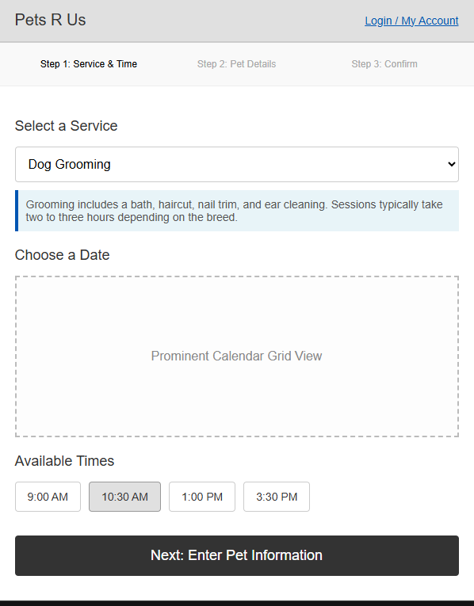

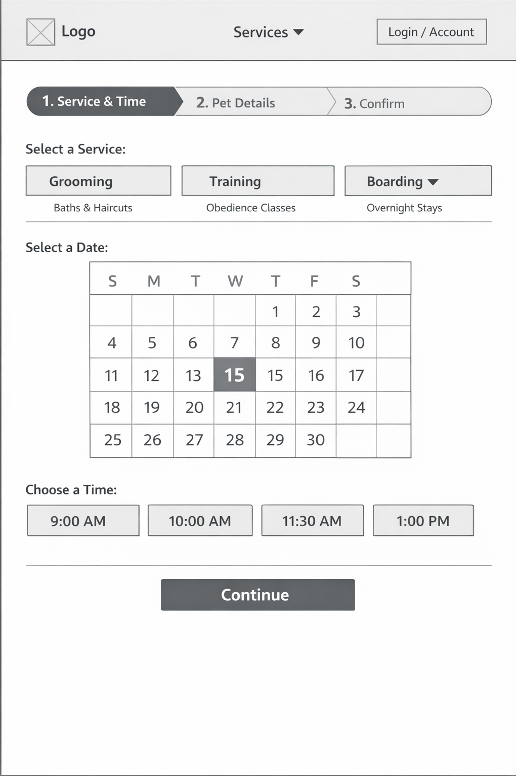
Challenges and Lessons Learned
One of the most significant challenges our team faced during this project was coordinating our schedules. Because our team members are located in different time zones and have busy daily routines, finding overlapping times to meet and collaborate on activities was very difficult.
This challenge taught us a valuable lesson about the importance of proactive and clear communication. I learned that to succeed in teamwork, especially in a remote or asynchronous environment, team members must communicate their availability early, set clear expectations, and stay organized. By keeping each other updated and actively coordinating our efforts, we were able to overcome our scheduling conflicts and successfully complete the project.

